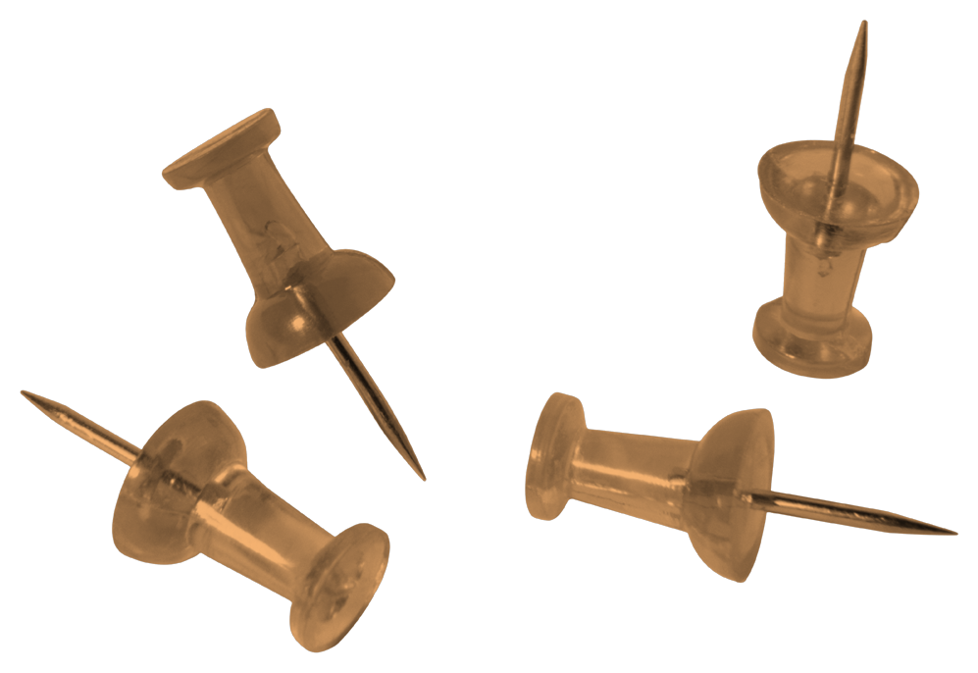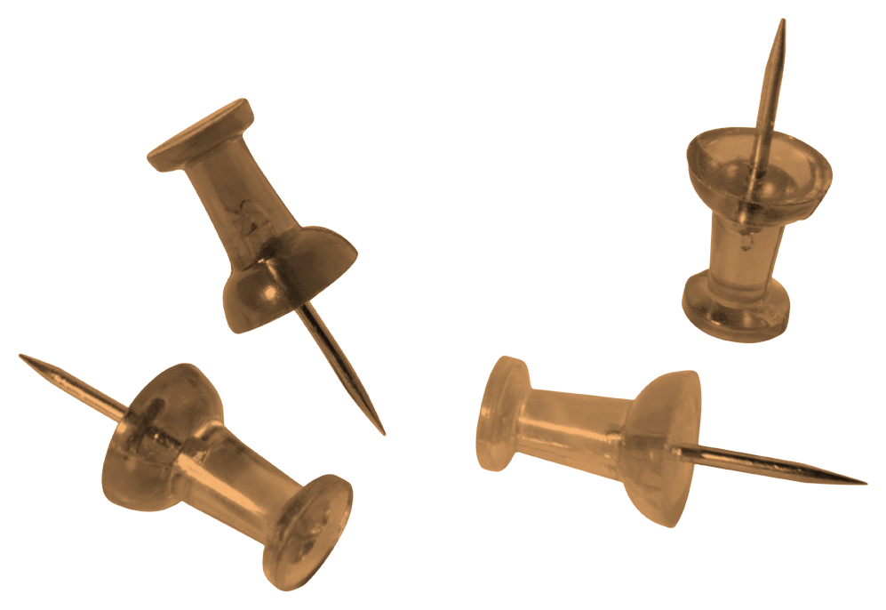
Screen Time Habits & Chores

Parents & Guardians,

The following is a sample of a daily chart that you can use to help your kids develop habits of being productive members of your family and to help them prioritize the important things before getting on screens. Adapt it to fit your family’s needs and routines.

Additionally, Summertime and breaks can be especially challenging for families to manage when the regular rhythms of school are not in place. Use the Screentime checklist along with the chore schedule to help your kids stay on track and be active participants in the daily rhythms of home and family.

No Screen Time Until…

- The puppies have been taken out and fed.

- You have eaten breakfast, cleaned up your dishes, and put everything you took out back into the cabinets.

- You put on your clothes, brush teeth and hair.

- Your bed is made, and your room & closet is clean
(clothes/papers/toys/technology).

- You have read a book for 20 minutes.

- You have had your devotion time and written in your journal.
-Read your memory verse out loud or write it one time.
-Have prayer time…you can write your prayer or make a list of things to pray about.
-Write a paragraph about yesterday (or the past week during the school year).

- You have done something creative, productive, or active for
at least 30 minutes & cleaned up after yourself.

- You have done at least one chore on your chore chart.

- Extra Chores You Can Do –
(To be done 1x each week by 1 child. Only one extra chore per child per day.
Earn an extra $1 per chore in your paycheck)

- Pull weeds in beds in back yard.
Done by:______________
- Clean front & back door glass.
Done by:______________
- Take coupons out of the newspaper.
Done by:______________
- Water plants inside and outside on front & back porch.
Done by:______________
- Pull weeds in beds in front yard.
Done by:______________
- Wipe the baseboards upstairs.
Done by:______________
- Wipe the baseboards downstairs.
Done by:______________
- Wash puppy bowls, beds, etc. and put them away.
Done by:______________
- Give puppies a bath.
Done by:______________

Bible Memory
Proverbs 3:5-6

⁵Trust in the Lord with all your heart;
and lean not on your own understanding.
⁶In all thy ways acknowledge him,
and he will make your path straight.

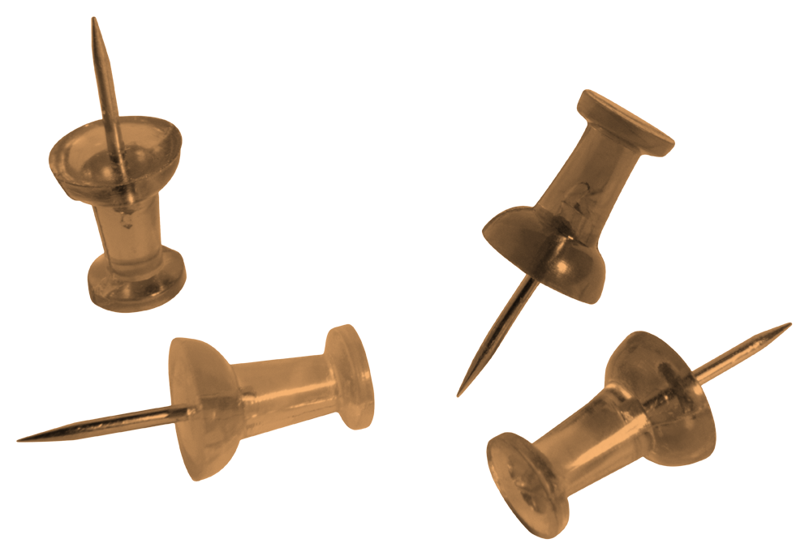
Kids To Do List
Week of __________________

DAILY TO DO’s:
(Circle your initial after you have finished your chores each day.)
 | MONDAY | TUESDAY | WEDNESDAY | THURSDAY | FRIDAY | SATURDAY
Let Dogs out | E B M | E B M | E B M | E B M | E B M | E B M
Feed Dogs #1 | E B M | E B M | E B M | E B M | E B M | E B M
Get Dressed | E B M | E B M | E B M | E B M | E B M | E B M
Time with God | E B M | E B M | E B M | E B M | E B M | E B M
Eat Breakfast | E B M | E B M | E B M | E B M | E B M | E B M
Make Bed | E B M | E B M | E B M | E B M | E B M | E B M
Wash Face #1 | E B M | E B M | E B M | E B M | E B M | E B M
Brush Teeth #1 | E B M | E B M | E B M | E B M | E B M | E B M
Brush Hair | E B M | E B M | E B M | E B M | E B M | E B M
Pick up | E B M | E B M | E B M | E B M | E B M | E B M
Clean up Room | E B M | E B M | E B M | E B M | E B M | E B M
Eat Lunch | E B M | E B M | E B M | E B M | E B M | E B M
Feed Dogs #2 | E B M | E B M | E B M | E B M | E B M | E B M
Read | E B M | E B M | E B M | E B M | E B M | E B M
Play a Game | E B M | E B M | E B M | E B M | E B M | E B M
Walk the Dogs | E B M | E B M | E B M | E B M | E B M | E B M
Journal | E B M | E B M | E B M | E B M | E B M | E B M
Creative Time | E B M | E B M | E B M | E B M | E B M | E B M
Feed Dogs #3 | E B M | E B M | E B M | E B M | E B M | E B M
Shower | E B M | E B M | E B M | E B M | E B M | E B M
Wash Face #2 | E B M | E B M | E B M | E B M | E B M | E B M
Brush Teeth #2 | E B M | E B M | E B M | E B M | E B M | E B M

Weekly Paid Chores

 | MONDAY | TUESDAY | WEDNESDAY | THURSDAY
Take Out All Trash $2 | E B M | E B M | E B M | E B M
Clean Bathrooms $3 | E B M | E B M | E B M | E B M
Vacuum $3 | E B M | E B M | E B M | E B M
Dust $3 | E B M | E B M | E B M | E B M
Brush the Dogs $2 | E B M | E B M | E B M | E B M
Mop hard floors $3 | E B M | E B M | E B M | E B M
 | E B M | E B M | E B M | E B M
 | E B M | E B M | E B M | E B M
 | E B M | E B M | E B M | E B M

**All Hands on Deck: We all contribute to helping with meal prep and kitchen cleanup after meals.

